Ideation Phase
Brainstorm & Idea Prioritization Template

Date | 26February 2026
Team ID | LTVIP2026TMIDS80402
Project Name | Order on you go
Maximum Marks | 4 Marks

Brainstorm & Idea Prioritization Template:

Step-1: Team Gathering, Collaboration and Select the Problem Statement

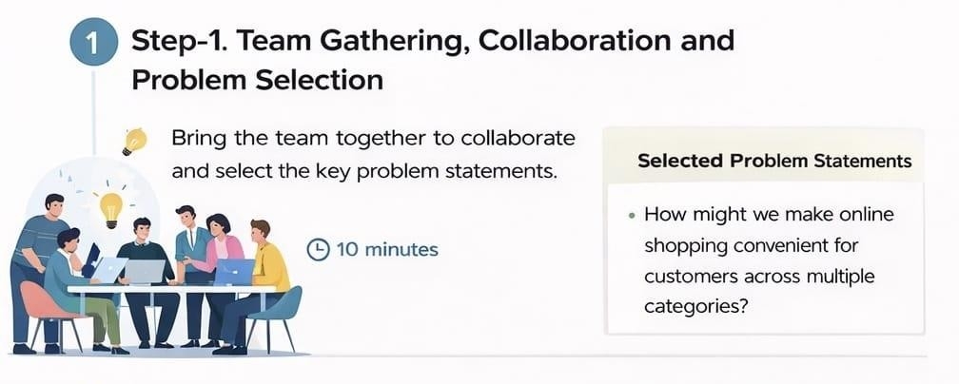

Step-2: Brainstorm, Idea Listing and Grouping
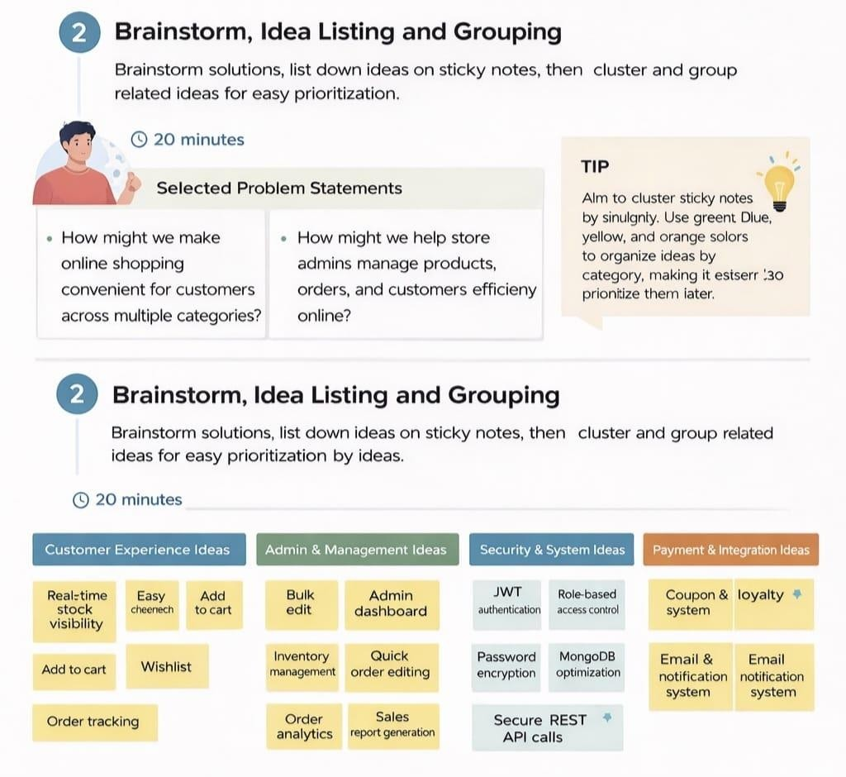

Step-3: Idea Prioritization
